Module 5 - Spring Core and Maven
Exercise 1: Configuring a Basic Spring Application
Program Code:
Project Structure:
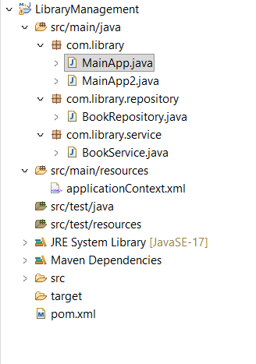
pom.xml:
<project xmlns="http://maven.apache.org/POM/4.0.0"
xmlns:xsi="http://www.w3.org/2001/XMLSchema-instance"
xsi:schemaLocation="http://maven.apache.org/POM/4.0.0 https://maven.apache.org/xsd/maven-4.0.0.xsd">
<modelVersion>4.0.0</modelVersion>
<groupId>com.library</groupId>
<artifactId>LibraryManagement</artifactId>
<version>0.0.1-SNAPSHOT</version>

<dependencies>
<dependency>
<groupId>org.springframework</groupId>
<artifactId>spring-context</artifactId>
<version>6.1.10</version> </dependency>
</dependencies>

<build>
<plugins>
<plugin>
<groupId>org.apache.maven.plugins</groupId>
<artifactId>maven-compiler-plugin</artifactId>
<version>3.11.0</version>
<configuration>
<source>17</source>
<target>17</target>
</configuration>
</plugin>
</plugins>
</build>
</project>

applicationContext.xml :
<bean id="bookRepository" class="com.library.repository.BookRepository" />
<bean id="bookService" class="com.library.service.BookService" />

BookRepository class :
package com.library.repository;

public class BookRepository {
public void saveData() {
System.out.println("Book data saved successfully to the database!");
}
}

BookService class :

package com.library.service;

import com.library.repository.BookRepository;

public class BookService {
private BookRepository bookRepository;

// Setter method for Spring to inject BookRepository
public void setBookRepository(BookRepository bookRepository) {
this.bookRepository = bookRepository;
}

public void addBook() {
System.out.println("Service: Attempting to add a book...");
bookRepository.saveData();
}
}

MainApp.java:
package com.library;

import org.springframework.context.ApplicationContext;
import org.springframework.context.support.ClassPathXmlApplicationContext;
import com.library.repository.BookRepository;

public class MainApp {
public static void main(String[] args) {
System.out.println("--- Exercise 1: Initializing Spring Context ---");

// 1. Load the Spring XML configuration file to start the IoC Container
ApplicationContext context = new ClassPathXmlApplicationContext("applicationContext.xml");

System.out.println("Spring Context loaded successfully!");

// 2. Retrieve the BookRepository bean directly from the container to test configuration
BookRepository bookRepository = (BookRepository) context.getBean("bookRepository");

// 3. Call a method to verify the bean works
bookRepository.saveData();

// Close the context resource
((ClassPathXmlApplicationContext) context).close();
}
}

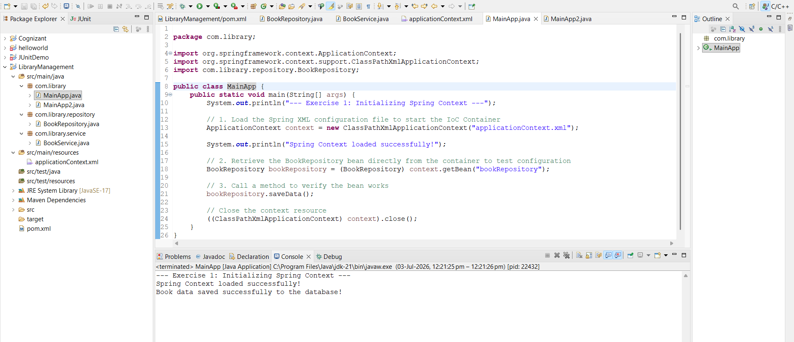

Exercise 2 - Implementing Dependency Injection:
Program :
applicationContext.xml :
<?xml version="1.0" encoding="UTF-8"?>
<beans xmlns="http://www.springframework.org/schema/beans"
xmlns:xsi="http://www.w3.org/2001/XMLSchema-instance"
xsi:schemaLocation="http://www.springframework.org/schema/beans
https://www.springframework.org/schema/beans/spring-beans.xsd">

<bean id="bookRepository" class="com.library.repository.BookRepository" />

<bean id="bookService" class="com.library.service.BookService">
<property name="bookRepository" ref="bookRepository" />
</bean>

</beans>

MainApp.java :

package com.library;

import org.springframework.context.ApplicationContext;
import org.springframework.context.support.ClassPathXmlApplicationContext;
import com.library.service.BookService;

public class MainApp {
public static void main(String[] args) {
// 1. Load the Spring XML configuration file
ApplicationContext context = new ClassPathXmlApplicationContext("applicationContext.xml");

// 2. Retrieve the configured BookService bean from the container
BookService bookService = (BookService) context.getBean("bookService");

// 3. Call the method to test if dependency injection succeeded
bookService.addBook();

// Close the context resource
((ClassPathXmlApplicationContext) context).close();
}
}
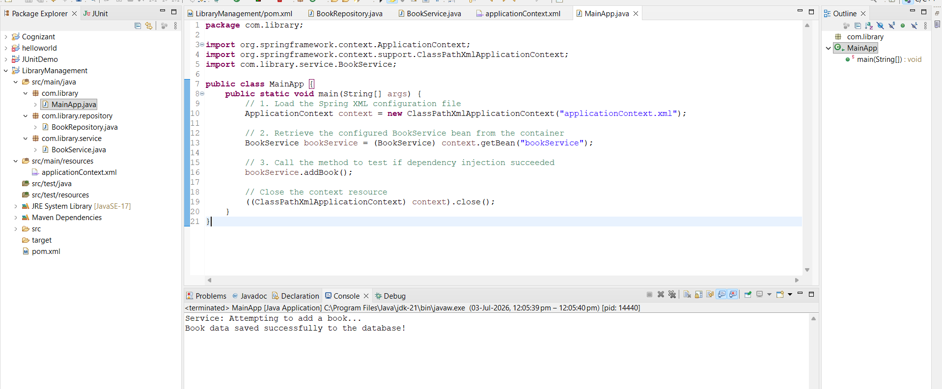

Exercise 4: Creating and Configuring a Maven Project
pom.xml :
<project xmlns="http://maven.apache.org/POM/4.0.0"
xmlns:xsi="http://www.w3.org/2001/XMLSchema-instance"
xsi:schemaLocation="http://maven.apache.org/POM/4.0.0 https://maven.apache.org/xsd/maven-4.0.0.xsd">
<modelVersion>4.0.0</modelVersion>
<groupId>com.library</groupId>
<artifactId>LibraryManagement</artifactId>
<version>0.0.1-SNAPSHOT</version>
<packaging>war</packaging> <properties>
<spring.version>5.3.31</spring.version>
</properties>

<dependencies>
<dependency>
<groupId>org.springframework</groupId>
<artifactId>spring-context</artifactId>
<version>${spring.version}</version>
</dependency>

<dependency>
<groupId>org.springframework</groupId>
<artifactId>spring-aop</artifactId>
<version>${spring.version}</version>
</dependency>

<dependency>
<groupId>org.springframework</groupId>
<artifactId>spring-webmvc</artifactId>
<version>${spring.version}</version>
</dependency>
</dependencies>

<build>
<plugins>
<plugin>
<groupId>org.apache.maven.plugins</groupId>
<artifactId>maven-compiler-plugin</artifactId>
<version>3.11.0</version>
<configuration>
<source>1.8</source>
<target>1.8</target>
</configuration>
</plugin>
</plugins>
</build>
</project>

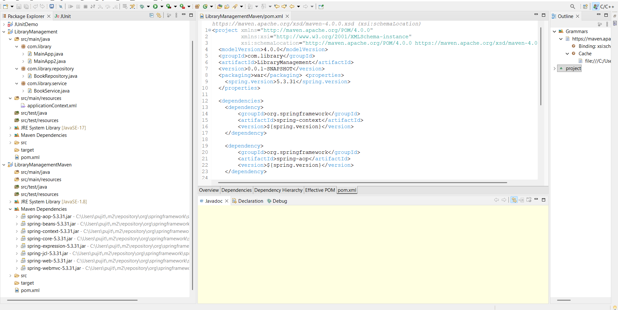
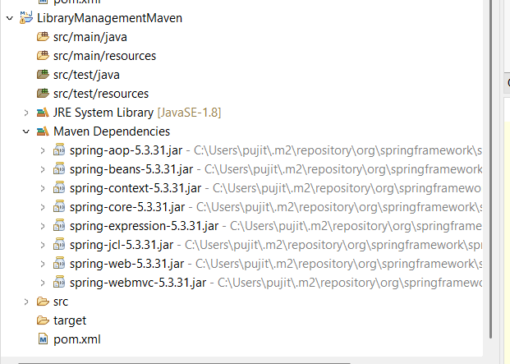

Exercise 5: Configuring the Spring IoC Container
applicationContext.xml :
<?xml version="1.0" encoding="UTF-8"?>
<beans xmlns="http://www.springframework.org/schema/beans"
xmlns:xsi="http://www.w3.org/2001/XMLSchema-instance"
xsi:schemaLocation="http://www.springframework.org/schema/beans
https://www.springframework.org/schema/beans/spring-beans.xsd">

<bean id="bookRepository" class="com.library.repository.BookRepository" />

<bean id="bookService" class="com.library.service.BookService">
<property name="bookRepository" ref="bookRepository" />
</bean>

</beans>

BookRepository.java :
package com.library.repository;

public class BookRepository {
public void saveData() {
System.out.println("Database: Book record successfully saved!");
}
}

BookService.java :
package com.library.service;

import com.library.repository.BookRepository;

public class BookService {
private BookRepository bookRepository;

// Setter method used by Spring IoC container for dependency injection
public void setBookRepository(BookRepository bookRepository) {
this.bookRepository = bookRepository;
}

public void addBook() {
System.out.println("Service: Delegating book addition to Repository...");
bookRepository.saveData();
}
}

LibraryManagementApplication.java :
package com.library;

import org.springframework.context.ApplicationContext;
import org.springframework.context.support.ClassPathXmlApplicationContext;
import com.library.service.BookService;

public class LibraryManagementApplication {
public static void main(String[] args) {
System.out.println("=== Exercise 5: Bootstrapping IoC Container ===");

// 1. Load configuration metadata into the ApplicationContext
ApplicationContext context = new ClassPathXmlApplicationContext("applicationContext.xml");

// 2. Retrieve the fully wired bean container instance
BookService bookService = (BookService) context.getBean("bookService");

// 3. Invoke methods to verify configuration success
bookService.addBook();

// 4. Close the context context channel safely
((ClassPathXmlApplicationContext) context).close();
}
}

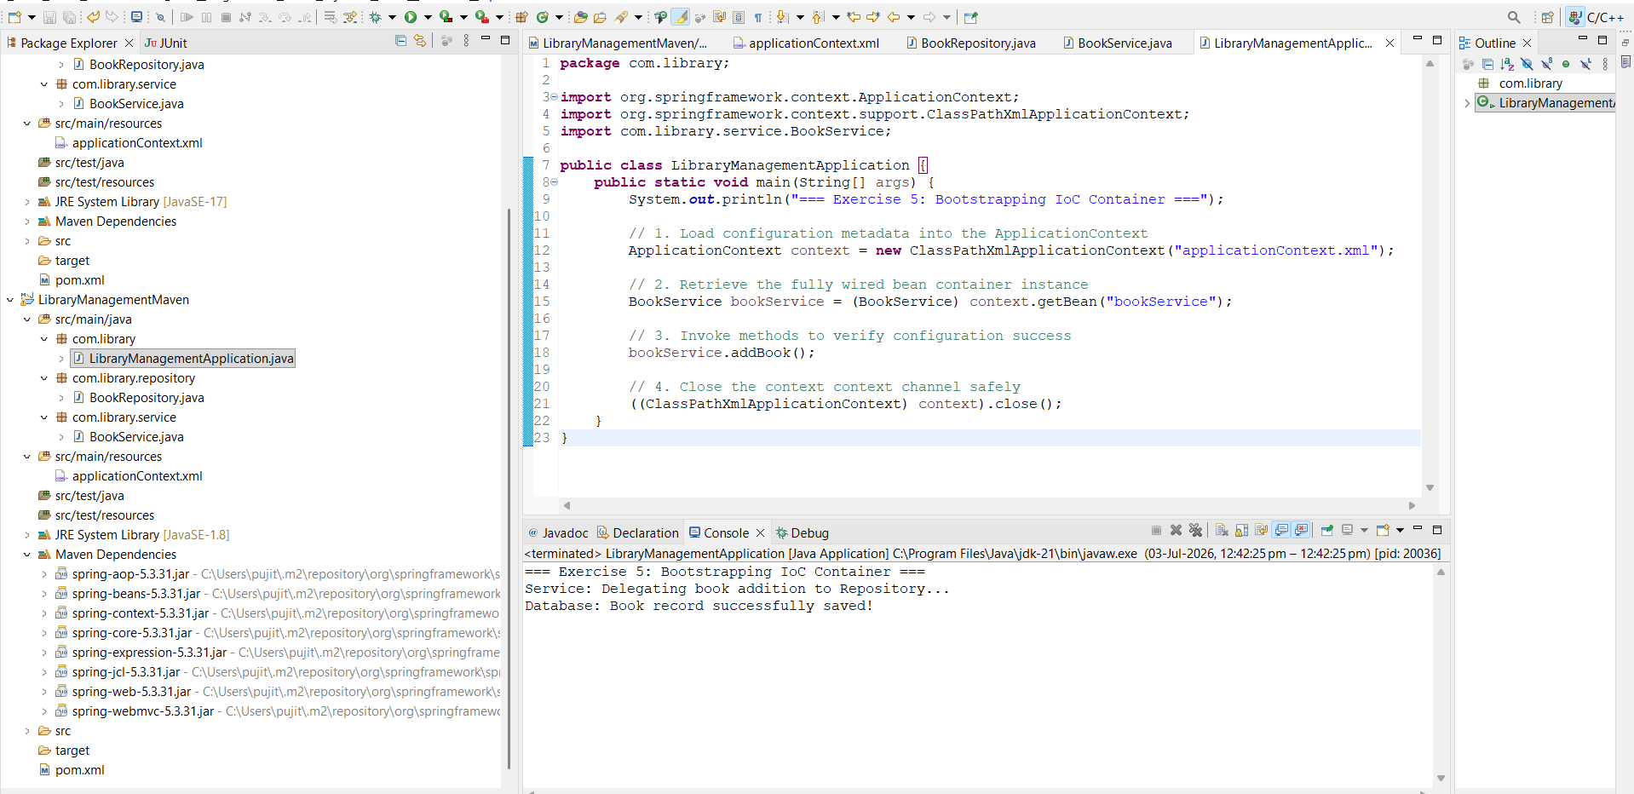

Exercise 7: Implementing Constructor and Setter Injection
NotificationService.java :
package com.library.service;

public class NotificationService {
public void sendNotification(String message) {
System.out.println("Notification: " + message);
}
}

BookService.java :
package com.library.service;

import com.library.repository.BookRepository;

public class BookService {
private BookRepository bookRepository;
private NotificationService notificationService;

// 1. CONSTRUCTOR INJECTION: For NotificationService
public BookService(NotificationService notificationService) {
this.notificationService = notificationService;
System.out.println("-> Constructor Injection: NotificationService injected.");
}

// 2. SETTER INJECTION: For BookRepository
public void setBookRepository(BookRepository bookRepository) {
this.bookRepository = bookRepository;
System.out.println("-> Setter Injection: BookRepository injected.");
}

public void addBook() {
System.out.println("Service: Adding a new book record...");
bookRepository.saveData();
notificationService.sendNotification("Book added successfully!");
}
}

applicationContext.xml :
<?xml version="1.0" encoding="UTF-8"?>
<beans xmlns="http://www.springframework.org/schema/beans"
xmlns:xsi="http://www.w3.org/2001/XMLSchema-instance"
xsi:schemaLocation="http://www.springframework.org/schema/beans
https://www.springframework.org/schema/beans/spring-beans.xsd">

<bean id="bookRepository" class="com.library.repository.BookRepository" />
<bean id="notificationService" class="com.library.service.NotificationService" />

<bean id="bookService" class="com.library.service.BookService">

<constructor-arg ref="notificationService" />

<property name="bookRepository" ref="bookRepository" />

</bean>

</beans>

LibraryManagementApplication
package com.library;

import org.springframework.context.ApplicationContext;
import org.springframework.context.support.ClassPathXmlApplicationContext;
import com.library.service.BookService;

public class LibraryManagementApplication {
public static void main(String[] args) {
System.out.println("=== Exercise 5: Bootstrapping IoC Container ===");

// 1. Load configuration metadata into the ApplicationContext
ApplicationContext context = new ClassPathXmlApplicationContext("applicationContext.xml");

// 2. Retrieve the fully wired bean container instance
BookService bookService = (BookService) context.getBean("bookService");

// 3. Invoke methods to verify configuration success
bookService.addBook();

// 4. Close the context context channel safely
((ClassPathXmlApplicationContext) context).close();
}
}

